Nigel Gambiza
M00951628
Super Market Management System Report

https://github.com/ng621/Supermarket-Management-system.git

Table of contents
Introduction………………………………….3
Data Structures………………………………3
Time Complexity……………………………4
Pseudocode………………………………….4
Testing………………………………………8
Reflection…………………………………...8
Diagrams……………………………………9
References………………………………….10

Introduction

This report is about a supermarket management system. The local supermarket owner has been complaining that using paper records, tracking stock levels, sales, suppliers and products using traditional methods is time consuming and inefficient. For example there is no way to know that stocks are low until an employee physically runs through the product in question, now imagine that method for a whole supermarket, human error is big problem. A lapse in concentration can cause a catalyst of problems down the supermarket lifecycle. What the system provides is inventory management, recording of sales, and an efficient way of searching for goods within the store. This report shows which methods and measures were taken to deliver this project and the supermarkets’ requirements.
Data Structures and algorithm Justification

For the supermarket I chose the Hash Table structure. This operation is designed for exact match lookups, which in turn is perfect for the supermarket because the operation will be using a barcode as its key, and a specific product can only have one barcode number, which allows us to instantly retrieve that exact products details.
O(1) is the right fit for barcode scanning because it is a time critical operation, within the context of a supermarket, the cashiers need to save time serving customers so this is the best fit for the supermarket.
The Hash Table achieves O(1) by using a concept called Hash to bucket. A Hash function takes the barcode string and then computes it into a numeric hash code, after that it then maps that hash to an array index, it then has access to that array directly jumping straight to that bucket in O(1) time, in the event that there are multiple barcodes that land in the same bucket, they are then stored as linked lists, which is called chaining. The advantages of this is that it allows very fast insertion and deletion, it relatively easier to implement that’s if there are no tree rotations. The disadvantages of are collisions, this is when multiple keys hash to the same bucket, which then degrades its performance to O(n) in that bucket. Another challenge it faces is that it is in no sorted order, meaning that it cannot traverse products alphabetically.
The Binary Search Tree (BST) is made for ordered name based lookups, specifically finding products by their name or title, in the context of the supermarket a BST would be used for searching for a product when the employee does not know \the barcode, which is the case in most cases. It allows for browsing for products alphabetically, and lastly getting a sorted list of all the products. BST achieves O(log n) by simply halving the search space at each step.
This is beneficial because it works with exponential improvement, with 1000 products it would have 10 comparisons (2^10 = 1024), whereas linear search O(n) would need to check all 1000 products until it finds “Milk”.
The bonus that BST gives you over the hash table is that it sorts products into alphabetical order from in order traversal. This means that there is no need for sorting algorithms, no O(n log n) sorting costs.
The choice of two structures as compared to one is that each data structure is optimally designed for a specific access pattern, neither can effectively replace the other one without sacrificing performance for critical operations.
The Hash table is best used for barcode scanning, reason being its fast and provides exact lookups during check out.
Supporting points:
- The O(1) average time complexity. (Sedgewick et al., 2011)
- Direct addressing, it will go straight to the product in question without searching
- Critical for a super markets customer service, it saves time.
Whereas BST would be slow when searching for products customers would notice the delay. Barcodes are random and BST wouldn’t be able to cope well, as it is not best tool for the required operation.
BST is best used for alphabetical name based operations, for ordered lookups and alphabetical product browsing.
Supporting points:
- O(log n) name search, efficient when one doesn’t know a products barcode
- Free alphabetical ordering, in order traversal produces sorted list
- Range queries, BST can get products between two limits e.g. between “D” and “J”
While Hash table would fail at sort all the products O(n log n) to get the alphabetical list first, Hash table would also require a separate sorting mechanism for every “list all products” operation.
The decision to incorporate two separate in memory indexes shows that there is no single data structure that can optimally serve the supermarkets’ wants especially with the nature of its operations. The Hash Table provides the O(1) lookups essential for real time barcode scanning, whilst the BST delivers ordered traversal capabilities critical for product browsing and management interfaces. This double architecture eliminates the performance compromises that would come up from using either structure solely, ensuring that both cashier and administrative operations execute at peak efficiency.
All data structures were implemented from scratch using array backed chained hash table buckets and recursive tree nodes, rather than relying on in built collections.

Time Complexity & Pseudocode
Find by barcode (Hash Table)
FUNCTION FindByBarcode(barcode):
Index = Hash (barcode) mod arraySize
Node = buckets[index]
WHILE node is not null:
IF node.key == barcode:
RETURN node.value
node = node.next
RETURN
Complexity: O(1) average, O(n) worst case.
Hashing jumps straight to one bucket, so lookup is constant on average. In the worst case all keys collide into one bucket, degrading the chain walk to linear.

Find by Name (BST)
FUNCTION FindByName(name):
current = root
WHILE current is not null:
comparison = Compare(name, current.name)
IF comparison == 0:
RETURN current.value
ELSE IF comparison < 0:
current = current.left
ELSE:
current = current.right
RETURN null
Complexity: O(log n) average, O(n) worst case
Each comparison wipes out half the remaining tree, halving the search space with each step. The logic remains intact when the tree remains intact. In the worst case, an unbalanced tree then degenerates into a linked list, requiring a full traversal of all n nodes.

Add Product
FUNCTION AddProduct(product, quantity, reorderLevel):
IF barcodeIndex.Get(product.barcode) is not null:
RETURN "Duplicate barcode"
IF string.IsNullOrWhiteSpace(product.title):
RETURN "Title required"
IF product.price <= 0:
RETURN "Price must be positive"
IF quantity < 0:
RETURN "Quantity cannot be negative"
context.Products.Add(product)
context.SaveChanges() // assigns ProductId
stock = new Stock(product.ProductId, quantity, reorderLevel)
context.Stocks.Add(stock)
context.SaveChanges()
barcodeIndex.Add(product.barcode, product)
nameIndex.Insert(product.title, product)
RETURN null
Complexity: O(log n) average
The operation is controlled by the BST insertion as it must traverse the tree to find the correct position while maintaining sorted order

Update Stock
FUNCTION UpdateStock(productId, quantitySold):
stock = context.Stocks.FirstOrDefault(s => s.ProductId == productId)
IF stock is null:
RETURN "Product not found in inventory"
IF stock.QuantityInStock < quantitySold:
RETURN "Insufficient stock"
stock.QuantityInStock -= quantitySold
context.SaveChanges()
RETURN null
Complexity: O(n) over stock rows, O(1) with indexed lookup
The primary cost is finding the right stock record. Without a DB index on the ProductId, this requires scanning all stock rows. With an index, this becomes O(1).

Record a sale
FUNCTION RecordSale(barcode, quantity):
product = barcodeIndex.Get(barcode)
IF product is null:
RETURN "Product not found"
stock = GetStockByProductId(product.ProductId)
IF stock.QuantityInStock < quantity:
RETURN "Insufficient stock"
sale = new Sale(DateTime.Now)
context.Sales.Add(sale)
saleItem = new SaleItem(sale.SaleId, product.ProductId, quantity, product.Price)
context.SaleItems.Add(saleItem)
stock.QuantityInStock -= quantity
context.SaveChanges()
RETURN null
Complexity: O(1) average for in memory parts, plus database writes
The barcode lookup is O(1) average using the hash table. The stock lookup and database operations add constant overhead. Multiple databases inserts occur (Sale, SaleItem, Stock update) but each is a single row operation.
Low Stock Report
FUNCTION GetLowStockReport():
results = empty list
FOR EACH stock in context.Stocks:
IF stock.QuantityInStock <= stock.ReorderLevel:
product = Products.Find(stock.ProductId)
results.Add(product.Title, stock.QuantityInStock, stock.ReorderLevel)
RETURN results sorted by product name
Complexity: O(n)
The report must examine every stock record in the system to determine which products have fallen below their reorder threshold. There is no way to skip directly to the low stock products without maintaining a separate index. This then provides a clean contrast to the O(1) and O(log n) operations, showcasing the linear cost of full system scans.
Complexity table
Operation | Data structure | Average Complexity | Worse Case
Find by barcode | Hash Table | O(1) | O(n)
Find by Name | Binary Search Tree | O(log n) | O(n)
Add Product | Both + DB | O(log n) | O(n)
Update Stock | Database | O(n) | O(n)
Record Sale | Hash Table + DB | O(1) | O(n)
Low Stock Report | DB scan | O(n) | O(n)

Key Insight
The two data structures both complement each other, the hash table provides constant time exact matches used for checkout scanning, while the binary search tree enables name searches and free alphabetical ordering for stock take operations.

Testing
For testing, the tests were written using the xUnit frame work, which was stored in a separate test project (Supermarket-Management-system.Tests), each test follows the same pattern which is:
SET UP PERFORM ACTION CHECK RESULT
Across the two data structures and the database persistence layer there were a total of 11 unit tests in total. The reason I chose testing in isolation is that it makes sure structures behave accordingly independently and proves that later changes would not break existing behavior.
The tests were grouped into three categories
Category | What it verifies
Hash Table | - Add then get returns value  - Missing key returns null  - Duplicate barcode rejected  - Multiple items retrievable via collisions  - Removal works
Binary Search Tree | - Insertthensearch  - Missing name returns null  - In order traversal returns alphabetical order  - Search is case insensitive
Database persistence | - A product saved through one context is read back through separate context.

EF Core’s in memory database provider for the persistence test, instead of the real database, because this keeps things fast, isolated and repeatable without a dependency on a live seeded database, this is effective because reading back through a second, separate context proves data genuinely persisted through the storage layer, and did not just stick in one object in memory. (Microsoft Entity Framework Core Documentation, 2025)
So a summary of the tests conducted were adding products, duplicate barcode validation, searching by name and barcode and the persistence, however a limitation is that the console UI layer and the sale recording logic are not unit tested.
Reflection
As it stands the system meets the core requirements requested by the Supermarket, fast barcode lookup, name search, stock tracking with reports showing low stocks, sales recording and persistence. The design for two data structures achieve their different goals, O(1) checkout scanning and O(log n) for ordered browsing, this then completes a fully functional foundation for a local supermarket.
Limitations
Although there are several limitations to this project, for sales it only registers one product per sale which is very unrealistic within the scope of a local supermarket. The console UI is built for strict narrow functionality there is no input recovery if a mistake were to happen. Unbalanced BST, worst case O(n) if products are inserted in sorted order a self balancing tree would guarantee O(log n). there is also no database transaction wrapper, the staggered sale operation could be only partially be completed if it were to be interrupted during a sale

Future improvements
Future improvements could include receipt printing, multi item baskets, advanced sales reports and a barcode scanner integration.
Diagrams
ERD
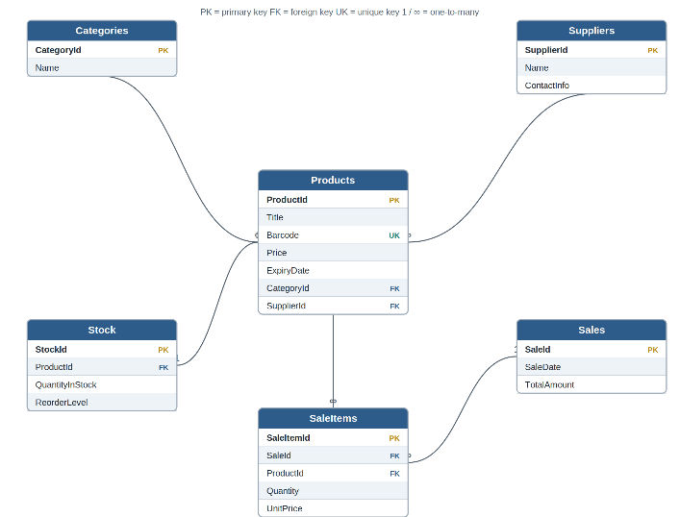 Fig1. six table schema
BST O(log n)
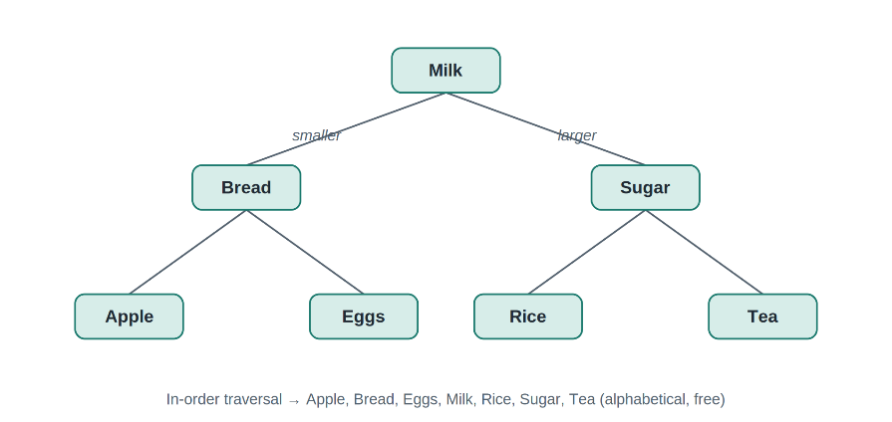Fig 2. BST example

Hash Table
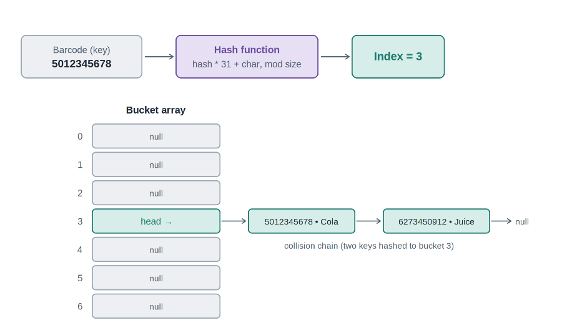Fig 3. Hash table example

References
- Sedgewick, R. and Wayne, K. (2011) Algorithms. 4th edn. Boston: Addison-Wesley.
- Microsoft (2025) Entity Framework Core documentation. Available at: https://learn.microsoft.com/en-us/ef/core/ (Accessed: 24 June 2026)
- Microsoft (2025) C# documentation. Available at: https://learn.microsoft.com/en-us/dotnet/csharp/ (Accessed: 24 June 2026).

